 | MATHEMATICS:SPECIALIST  SEMESTER 1 2017  TEST 2  Calculator free

Reading time: 2 minutes
Time Allowed: 35 minutes Total Marks: 34

1. [8 marks – 2, 1, 1, 4]
Given that 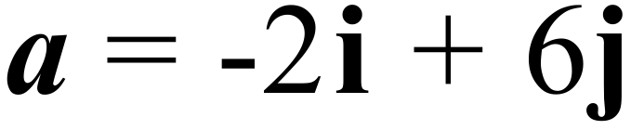 and 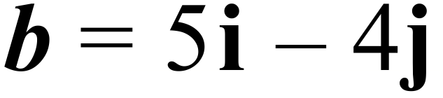 , find:
(a) | |

(b) the unit vector parallel to

(c) a vector that is parallel but with a magnitude of 5

(d) a in terms of p and q where 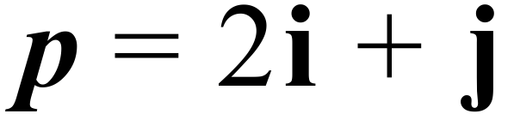 and 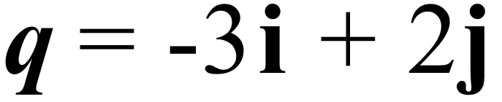

2. [5 marks]
.
Find c in terms of b if A, B and C are collinear.

3. [3 marks]
Write the mathematical notation for the statement:
For all rational numbers x, there exist integers y and w such that 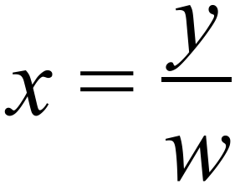 where w is non-zero.

4. [6 marks – 2, 2, 2]
The following statement is true:
If a polygon is a square then it is a quadrilateral
Write the converse, inverse and contrapositive statements and state whether each is true or false.
Converse

True / False?

Inverse

True / False?

Contrapositive

True / False?
5. [4 marks]
Prove that a triangle with one side of length 5x, another of length (12x+13) and the longest side of length (13x + 12), cannot be a right angled, using the method of proof by contradiction.

6. [3 marks]
If a = 4i - 6j , b= 2i + 6j and c = 4i - 2j prove that a is perpendicular to (b+c).

7. [3 marks]
Given 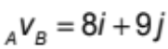 and 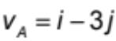, find 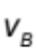

8. [2 marks]
Find the value of ‘k’ given that the vectors 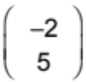and 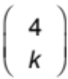 are perpendicular.

MATHEMATICS:SPECIALIST
SEMESTER 1 2017

TEST 2

Calculator Assumed

Reading time: 2 minutes
Time Allowed: 30 minutes Total Marks: 29
9. [2 marks]
Find the acute angle between the vectors a = 2i - 3j and b = 5i - 2j

10. [6 marks – 3, 3]
(a) Given that 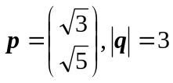 and that vectors p and q are perpendicular, find q.

(b) Find the value of b given that the angle between 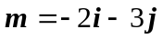 and 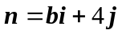 is 100°

11. [4 marks]
Points A and B have position vectors i +8j and 19i +2j respectively. Find the position vector of the point that divides AB internally in the ratio 1:4

12. [5 Marks]
If v_{A} = 65km/h in a direction of 050° and _{B}v_{A} = 80km/h in a direction of 120°, find v_{B}.

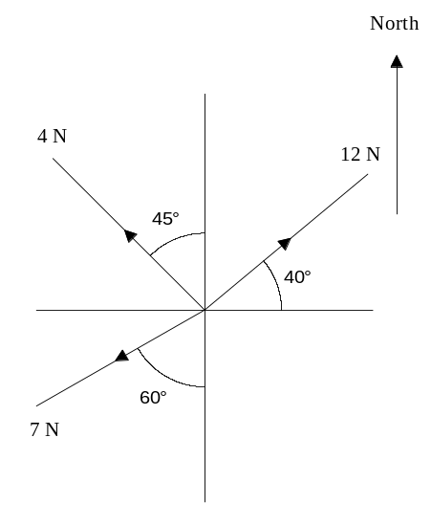
13. [6 marks – 4, 2]
The diagram right shows the forces acting on a body. [3,3]
The forces are all on the same plane.
- Find the magnitude of the resultant.

- Find the magnitude and direction of the single force that will keep this system in equilibrium.

14. [6 marks]

Jolan and Shana love roller derby. While competing at their local Rollerdome on Saturday evening, Shana’s GPS enabled phone told her that she was travelling with a velocity of
-4i + 7j m/s.

At this point in time it seemed to Shana that Jolan was travelling with a speed of 9 m/s (a very smart phone). Jolan later bragged to Shana that his Health Band told him he was actually moving at 15 m/s.

Find Jolan’s true velocity, in the form ai + bj, given a and b are both positive.
(give the values of a and b accurate to 1 decimal place).

